Segment Containment in a Plane

Definition
# Source: AI Source: Provided by: [Data Path: Persons Table -> ID Column: 1, Name_En Column: Motasem Essam] -> From: [ChatGPT] on [7/25/2026]
Segment Containment in a Plane occurs when an entire line segment lies within a plane.
If the line segment is $\overset{‾}{AB}$and the plane is $Π$, then:
$$\boxed{\overset{‾}{AB}⊂Π}$$
This means that every point of the segment belongs to the plane.
In point-by-point form:
$$\boxed{P∈\overset{‾}{AB}⇒P∈Π}$$
for every point $P$on the segment.
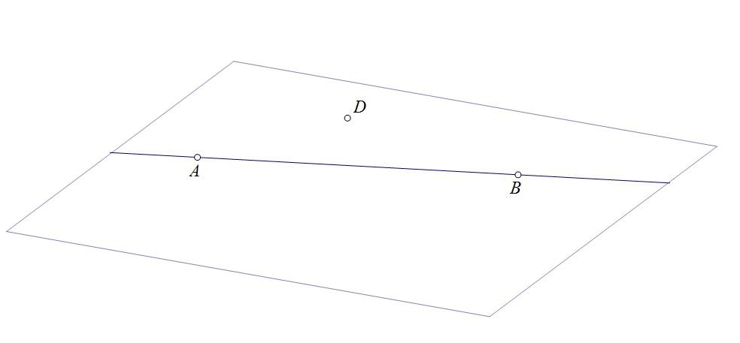
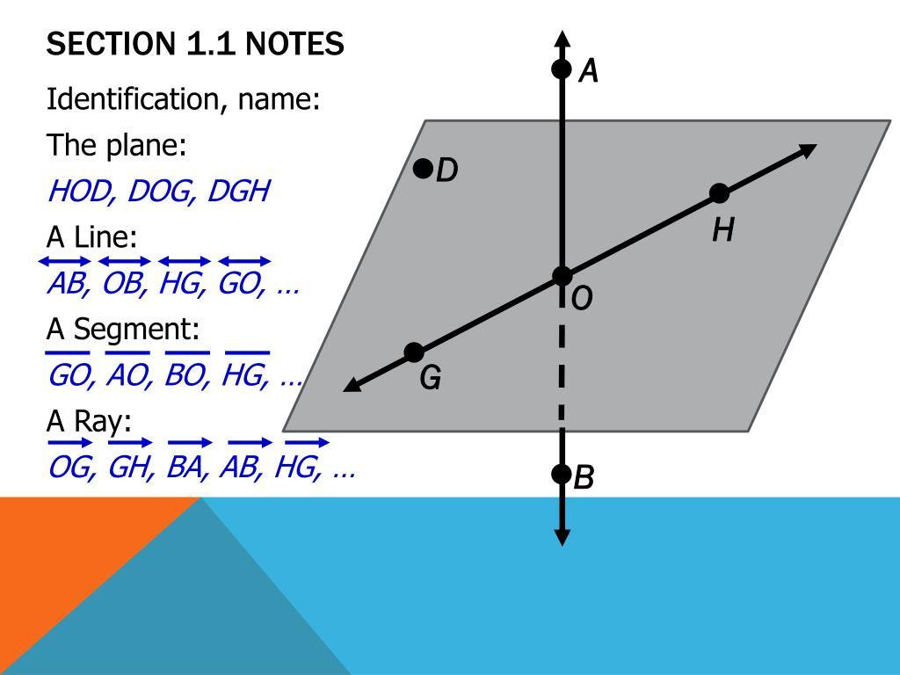
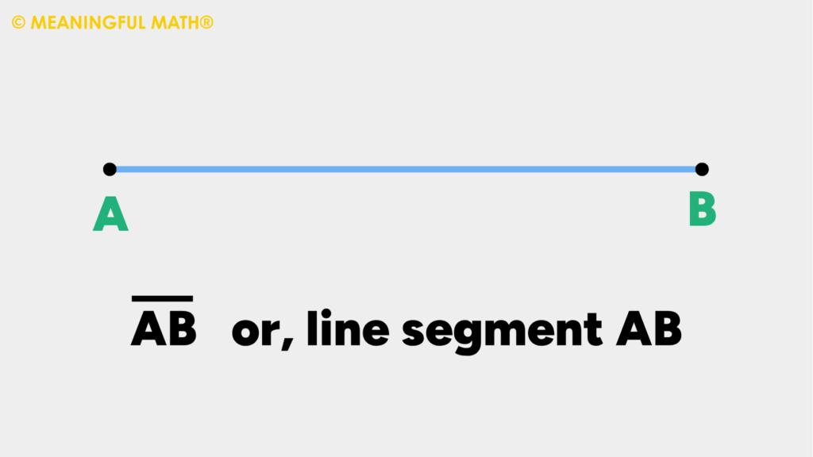

Purpose
# Source: AI Source: Provided by: [Data Path: Persons Table -> ID Column: 1, Name_En Column: Motasem Essam] -> From: [ChatGPT] on [7/25/2026]
Segment containment in a plane describes the positional relationship between:
- a finite one-dimensional object — the line segment;
- an infinite two-dimensional object — the plane.
It is useful for understanding:
- Plane Geometry
- Solid Geometry
- Analytic Geometry
- Vector Geometry
- 3D Coordinate Geometry
- CAD
- Engineering drawings
- Computer graphics

Fundamental Concept
# Source: AI Source: Provided by: [Data Path: Persons Table -> ID Column: 1, Name_En Column: Motasem Essam] -> From: [ChatGPT] on [7/25/2026]
A line segment has:
- two endpoints;
- finite length;
- infinitely many points between its endpoints.
A plane has:
- no boundary;
- infinite extent in two dimensions;
- infinitely many lines and segments lying within it.
If both endpoints of a segment lie in a plane, the entire segment connecting them lies in that plane.
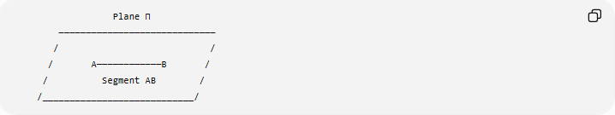
Plane Π
─────────────────────────────
/ /
/ A────────────B /
/ Segment AB /
/____________________________/
Thus:
$$\boxed{\overset{‾}{AB}⊂Π}$$

Fundamental Theorem
# Source: AI Source: Provided by: [Data Path: Persons Table -> ID Column: 1, Name_En Column: Motasem Essam] -> From: [ChatGPT] on [7/25/2026]
Segment–Plane Containment Theorem
If two distinct endpoints of a line segment lie in a plane, then the entire segment lies in that plane.
Given:
$$A∈Π$$
and:
$$B∈Π$$
with:
$$A≠B$$
then:
$$\boxed{\overset{‾}{AB}⊂Π}$$
Reason
A plane contains the entire line determined by any two distinct points in that plane:
$$A,B∈Π⇒\overset{↔}{AB}⊂Π$$
Since:
$$\overset{‾}{AB}⊂\overset{↔}{AB}$$
we obtain:
$$\boxed{\overset{‾}{AB}⊂Π}$$

Mathematical Representation
# Source: AI Source: Provided by: [Data Path: Persons Table -> ID Column: 1, Name_En Column: Motasem Essam] -> From: [ChatGPT] on [7/25/2026]
A segment can be represented parametrically as:
$$\boxed{\overset{‾}{AB}=\left\{\left(1-t\right)A+tB∣0≤t≤1\right\}}$$
If:
$$A,B∈Π$$
then every point
$$\left(1-t\right)A+tB$$
for:
$$0≤t≤1$$
also belongs to the plane.
Therefore:
$$\boxed{\overset{‾}{AB}⊂Π}$$

Convexity of a Plane
# Source: AI Source: Provided by: [Data Path: Persons Table -> ID Column: 1, Name_En Column: Motasem Essam] -> From: [ChatGPT] on [7/25/2026]
The reason the entire segment remains in the plane can also be understood through convexity.
A plane is a convex set.
Therefore, if:
$$A∈Π$$
and:
$$B∈Π$$
then every point on the segment joining $A$and $B$is also in the plane:
$$\boxed{A,B∈Π⇒\overset{‾}{AB}⊂Π}$$
This principle also applies to many other convex geometric regions.

Fundamental Elements
# Source: AI Source: Provided by: [Data Path: Persons Table -> ID Column: 1, Name_En Column: Motasem Essam] -> From: [ChatGPT] on [7/25/2026]
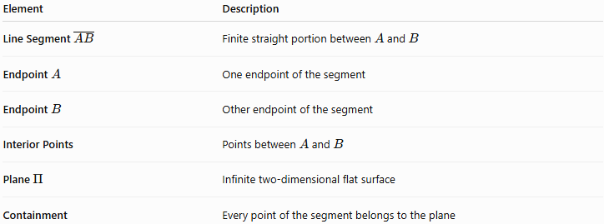
Element | Description
Line Segment $\overset{‾}{AB}$ | Finite straight portion between $A$and $B$
Endpoint $A$ | One endpoint of the segment
Endpoint $B$ | Other endpoint of the segment
Interior Points | Points between $A$and $B$
Plane $Π$ | Infinite two-dimensional flat surface
Containment | Every point of the segment belongs to the plane

Coordinate Representation
# Source: AI Source: Provided by: [Data Path: Persons Table -> ID Column: 1, Name_En Column: Motasem Essam] -> From: [ChatGPT] on [7/25/2026]
Suppose:
$$A=\left(x_{1} , y_{1} , z_{1}\right)$$
and:
$$B=\left(x_{2} , y_{2} , z_{2}\right)$$
The segment can be represented as:
$$\left(x , y , z\right)=\left(x_{1} , y_{1} , z_{1}\right)+t\left(x_{2} , - , x_{1}y_{2}-y_{1}z_{2}-z_{1}\right)$$
with:
$$\boxed{0≤t≤1}$$
Suppose the plane is:
$$Π:ax+by+cz=d$$
For the entire segment to be contained in the plane:
$$\boxed{ax\left(t\right)+by\left(t\right)+cz\left(t\right)=d}$$
must hold for every:
$$0≤t≤1$$
A simpler test is to check both endpoints:
$$\boxed{ax_{1}+by_{1}+cz_{1}=d}$$
and:
$$\boxed{ax_{2}+by_{2}+cz_{2}=d}$$
If both endpoints are in the plane, the entire segment is in the plane.

Example
# Source: AI Source: Provided by: [Data Path: Persons Table -> ID Column: 1, Name_En Column: Motasem Essam] -> From: [ChatGPT] on [7/25/2026]
Consider the plane:
$$Π:x+y+z=6$$
and the segment with endpoints:
$$A=\left(1 , 2 , 3\right)$$
and:
$$B=\left(3 , 1 , 2\right)$$
Check $A$
$$1+2+3=6$$
Therefore:
$$A∈Π$$
Check $B$
$$3+1+2=6$$
Therefore:
$$B∈Π$$
Since both endpoints lie in the plane:
$$\boxed{\overset{‾}{AB}⊂Π}$$
Therefore, every point between $A$and $B$also lies in the plane.

Example of a Segment Not Contained in a Plane
# Source: AI Source: Provided by: [Data Path: Persons Table -> ID Column: 1, Name_En Column: Motasem Essam] -> From: [ChatGPT] on [7/25/2026]
Consider:
$$Π:x+y+z=6$$
and:
$$A=\left(1 , 2 , 3\right) \\ B=\left(3 , 1 , 5\right)$$
For $A$:
$$1+2+3=6$$
so:
$$A∈Π$$
For $B$:
$$3+1+5=9$$
so:
$$B∉Π$$
Therefore:
$$\boxed{\overset{‾}{AB}⊄Π}$$
The segment leaves the plane.
In this situation, the segment may intersect the plane at one point.

Segment Containment Through Its Supporting Line
# Source: AI Source: Provided by: [Data Path: Persons Table -> ID Column: 1, Name_En Column: Motasem Essam] -> From: [ChatGPT] on [7/25/2026]
Every segment has a unique supporting line.
For:
$$\overset{‾}{AB}$$
the supporting line is:
$$\overset{↔}{AB}$$
We know:
$$\overset{‾}{AB}⊂\overset{↔}{AB}$$
If the supporting line is contained in the plane:
$$\overset{↔}{AB}⊂Π$$
then:
$$\boxed{\overset{‾}{AB}⊂\overset{↔}{AB}⊂Π}$$
Therefore:
$$\boxed{\overset{‾}{AB}⊂Π}$$
This gives a useful containment chain.

Segment–Plane Positional Relationships
# Source: AI Source: Provided by: [Data Path: Persons Table -> ID Column: 1, Name_En Column: Motasem Essam] -> From: [ChatGPT] on [7/25/2026]
A segment and a plane can have several positional relationships.
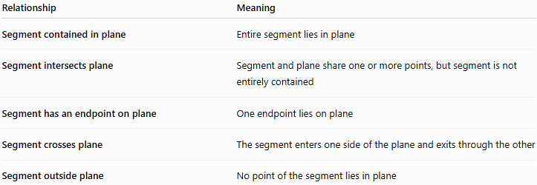
Relationship | Meaning
Segment contained in plane | Entire segment lies in plane
Segment intersects plane | Segment and plane share one or more points, but segment is not entirely contained
Segment has an endpoint on plane | One endpoint lies on plane
Segment crosses plane | The segment enters one side of the plane and exits through the other
Segment outside plane | No point of the segment lies in plane
The most important distinction is:
$$\boxed{\overset{‾}{AB}⊂Π}$$
versus:
$$\boxed{\overset{‾}{AB}∩Π=\left\{P\right\}}$$
The first represents containment; the second represents single-point intersection.

Segment Containment vs. Segment–Plane Intersection
# Source: AI Source: Provided by: [Data Path: Persons Table -> ID Column: 1, Name_En Column: Motasem Essam] -> From: [ChatGPT] on [7/25/2026]
If:
$$\overset{‾}{AB}⊂Π$$
then:
$$\boxed{\overset{‾}{AB}∩Π=\overset{‾}{AB}}$$
The intersection is the whole segment.
If the segment only crosses the plane:
$$\boxed{\overset{‾}{AB}∩Π=\left\{P\right\}}$$
where $P$is a single point.
Thus, containment is a special case of intersection where the entire smaller object is the common part.

Segment Containment vs. Line Containment in a Plane
# Source: AI Source: Provided by: [Data Path: Persons Table -> ID Column: 1, Name_En Column: Motasem Essam] -> From: [ChatGPT] on [7/25/2026]
These are closely related but different.
Line Containment
$$\boxed{\overset{↔}{AB}⊂Π}$$
The entire infinite line lies in the plane.
Segment Containment
$$\boxed{\overset{‾}{AB}⊂Π}$$
Only the finite segment is being considered.
If the line is contained in the plane, its segment is automatically contained:
$$\boxed{\overset{↔}{AB}⊂Π⇒\overset{‾}{AB}⊂Π}$$

Segment Containment vs. Point Containment in a Plane
# Source: AI Source: Provided by: [Data Path: Persons Table -> ID Column: 1, Name_En Column: Motasem Essam] -> From: [ChatGPT] on [7/25/2026]
These describe different levels of containment.
Point
$$P∈Π$$
One point belongs to the plane.
Segment
$$\overset{‾}{AB}⊂Π$$
Every point of an entire segment belongs to the plane.
Thus:
$$\boxed{P∈\overset{‾}{AB} \text{and} \overset{‾}{AB}⊂Π⇒P∈Π}$$

Segment Containment vs. Segment Containment in a Line
# Source: AI Source: Provided by: [Data Path: Persons Table -> ID Column: 1, Name_En Column: Motasem Essam] -> From: [ChatGPT] on [7/25/2026]
These are related but have different containing objects.
Segment in Line
$$\boxed{\overset{‾}{AB}⊂\overset{↔}{AB}}$$
A segment is contained in a line.
Segment in Plane
$$\boxed{\overset{‾}{AB}⊂Π}$$
A segment is contained in a plane.
The containment hierarchy is:
$$\boxed{\overset{‾}{AB}⊂\overset{↔}{AB}⊂Π}$$

Segment Containment and Coincidence
# Source: AI Source: Provided by: [Data Path: Persons Table -> ID Column: 1, Name_En Column: Motasem Essam] -> From: [ChatGPT] on [7/25/2026]
A segment and a plane cannot be coincident.
Coincidence means two geometric objects occupy exactly the same geometric set.
A segment is one-dimensional and finite, while a plane is two-dimensional and infinite.
Therefore:
$$\boxed{\overset{‾}{AB}⊊Π}$$
rather than:
$$\overset{‾}{AB}=Π$$

Segment Containment and Collinearity
# Source: AI Source: Provided by: [Data Path: Persons Table -> ID Column: 1, Name_En Column: Motasem Essam] -> From: [ChatGPT] on [7/25/2026]
If:
$$A,B,P$$
are collinear, then $P$may lie on the supporting line.
But that alone does not determine whether the segment is contained in a particular plane.
For segment-plane containment, the important condition is that the segment's points belong to the plane.
If:
$$A,B∈Π$$
then:
$$\overset{‾}{AB}⊂Π$$

Important Properties
# Source: AI Source: Provided by: [Data Path: Persons Table -> ID Column: 1, Name_En Column: Motasem Essam] -> From: [ChatGPT] on [7/25/2026]
1. The segment is finite
Unlike a line, a segment has two endpoints and finite length.
2. The plane is infinite
The plane extends indefinitely in two dimensions.
3. Every point of the segment lies in the plane
$$\boxed{P∈\overset{‾}{AB}⇒P∈Π}$$
4. Two endpoints are sufficient
For a straight segment:
$$\boxed{A,B∈Π⇒\overset{‾}{AB}⊂Π}$$
5. The supporting line is also contained
If both endpoints are in the plane:
$$\boxed{\overset{↔}{AB}⊂Π}$$
and therefore:
$$\boxed{\overset{‾}{AB}⊂Π}$$
6. Containment is transitive
If:
$$\overset{‾}{AB}⊂l$$
and:
$$l⊂Π$$
then:
$$\boxed{\overset{‾}{AB}⊂Π}$$

Geometric Dimension
# Source: AI Source: Provided by: [Data Path: Persons Table -> ID Column: 1, Name_En Column: Motasem Essam] -> From: [ChatGPT] on [7/25/2026]
The relationship can also be understood through dimensions:
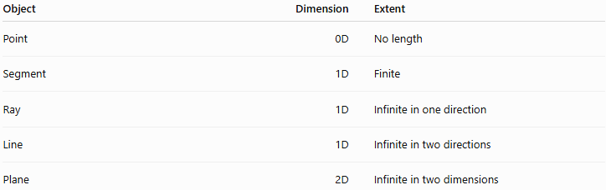
Object | Dimension | Extent
Point | 0D | No length
Segment | 1D | Finite
Ray | 1D | Infinite in one direction
Line | 1D | Infinite in two directions
Plane | 2D | Infinite in two dimensions
Thus:
$$\boxed{\text{Segment }\left(1D\right)⊂\text{Plane }\left(2D\right)}$$

Real-World Applications
# Source: AI Source: Provided by: [Data Path: Persons Table -> ID Column: 1, Name_En Column: Motasem Essam] -> From: [ChatGPT] on [7/25/2026]
Engineering
Straight edges of objects can be modeled as line segments contained within planar surfaces.
Architecture
A wall or floor plan can contain many line segments representing edges, boundaries, and structural elements.
CAD
Edges of planar faces are frequently represented as segments contained in those faces.
Computer Graphics
Polygon edges are line segments contained in the planes of polygonal surfaces.
Robotics
A robot moving along a straight path constrained to a flat surface can be represented using a segment contained in a plane.
Surveying
A measured finite path can be represented as a segment lying within a horizontal or vertical reference plane.

Comparison with Related Concepts
# Source: AI Source: Provided by: [Data Path: Persons Table -> ID Column: 1, Name_En Column: Motasem Essam] -> From: [ChatGPT] on [7/25/2026]
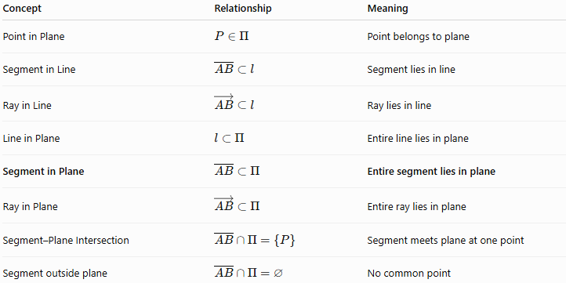
Concept | Relationship | Meaning
Point in Plane | $$P∈Π$$ | Point belongs to plane
Segment in Line | $$\overset{‾}{AB}⊂l$$ | Segment lies in line
Ray in Line | $$\vec{AB}⊂l$$ | Ray lies in line
Line in Plane | $$l⊂Π$$ | Entire line lies in plane
Segment in Plane | $$\overset{‾}{AB}⊂Π$$ | Entire segment lies in plane
Ray in Plane | $$\vec{AB}⊂Π$$ | Entire ray lies in plane
Segment–Plane Intersection | $$\overset{‾}{AB}∩Π=\left\{P\right\}$$ | Segment meets plane at one point
Segment outside plane | $$\overset{‾}{AB}∩Π=∅$$ | No common point

Containment Hierarchy
# Source: AI Source: Provided by: [Data Path: Persons Table -> ID Column: 1, Name_En Column: Motasem Essam] -> From: [ChatGPT] on [7/25/2026]
A useful hierarchy for your knowledge base is:
$$\boxed{\overset{‾}{AB}⊂\vec{AB}⊂\overset{↔}{AB}⊂Π}$$
This shows that a segment can be contained in a ray, the ray in a line, and the line in a plane.
More generally:
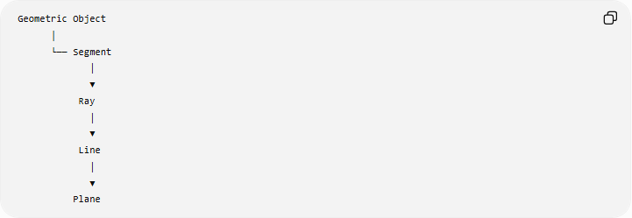
Geometric Object
│
└── Segment
│
▼
Ray
│
▼
Line
│
▼
Plane

Key Points
# Source: AI Source: Provided by: [Data Path: Persons Table -> ID Column: 1, Name_En Column: Motasem Essam] -> From: [ChatGPT] on [7/25/2026]
- Segment Containment in a Plane means an entire segment lies inside a plane.
- The notation is:
$$\boxed{\overset{‾}{AB}⊂Π}$$
- Every point of the segment belongs to the plane.
- If both endpoints lie in the plane, the entire segment lies in the plane.
- A plane is convex, which guarantees that the segment connecting two of its points remains in the plane.
- A segment is finite, whereas a plane is infinite.
- If the segment is contained in the plane:
$$\boxed{\overset{‾}{AB}∩Π=\overset{‾}{AB}}$$
- This is different from a segment that merely intersects a plane at one point.
- A segment contained in a line that is itself contained in a plane is automatically contained in that plane.
- Segment-plane containment is fundamental in 3D geometry, CAD, engineering, graphics, and spatial modeling.

Conclusion
# Source: AI Source: Provided by: [Data Path: Persons Table -> ID Column: 1, Name_En Column: Motasem Essam] -> From: [ChatGPT] on [7/25/2026]
Segment Containment in a Plane describes the complete inclusion of a finite line segment within an infinite plane:
$$\boxed{\overset{‾}{AB}⊂Π}$$
The most important principle is:
$$\boxed{A,B∈Π⇒\overset{‾}{AB}⊂Π}$$
Thus, when two distinct endpoints of a segment lie in the same plane, every point between them also lies in that plane. This makes segment containment in a plane an important link between point containment, segment containment in a line, line containment in a plane, and higher-dimensional geometric containment.

